**School of Computer Science**

**UNIVERSITY OF PETROLEUM AND ENERGY STUDIES**

**DEHRADUN, UTTARAKHAND**



**System Provisioning and**

**Configuration Management**

|  |  |
| --- | --- |
| Submitted To:  Dr. Hitesh Kumar Sharma | Submitted By:  Akshit Saini  Batch – 2(DevOps)  500094567 |

**Lab Exercise 4– Terraform Variables** **Objective:**

Learn how to define and use variables in Terraform configuration.

**Prerequisites:**

• Install Terraform on your machine.

**Steps:**

1. **Create a Terraform Directory:** 
   * Create a new directory for your Terraform project.

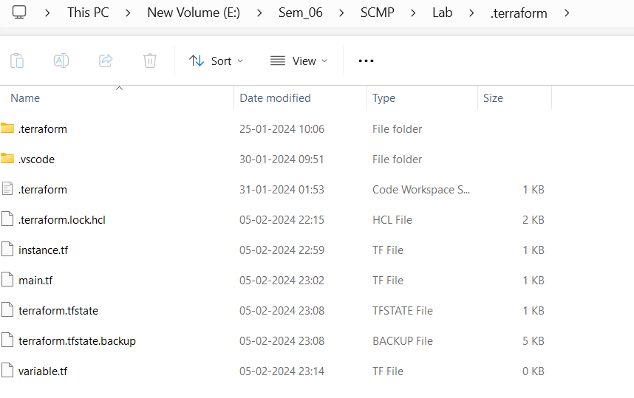

1. **Create a Terraform Configuration File:** 
   * Create a file named main.tf within your project directory.

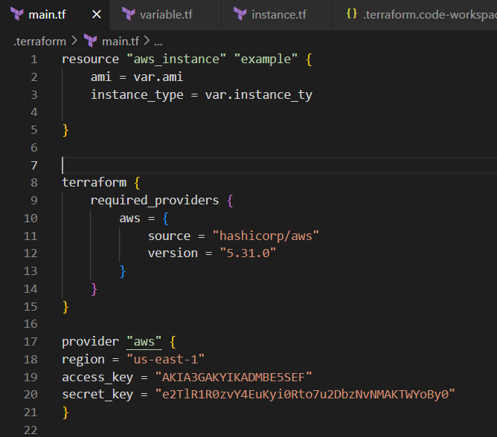

1. **Define Variables:** 
   * Open a new file named variables.tf. Define variables for region, ami, and instance_type.

**# variables.tf**

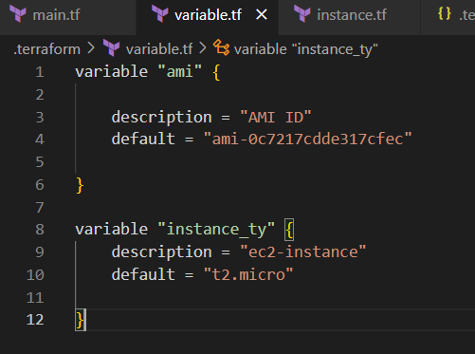

**Use Variables in main.tf:**

* + Modify main.tf to use the variables. **# main.tf**

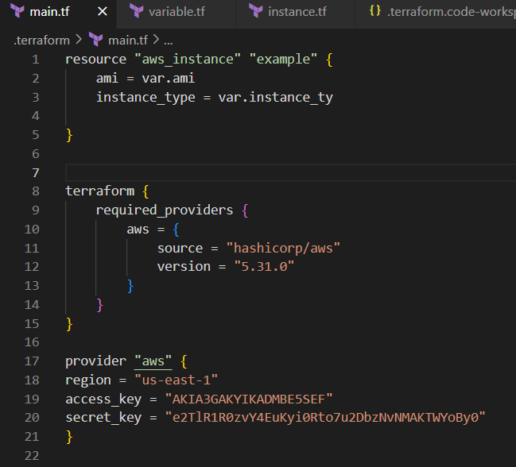

1. **Initialize and Apply:** 
   * Run the following Terraform commands to initialize and apply the configuration.
2. 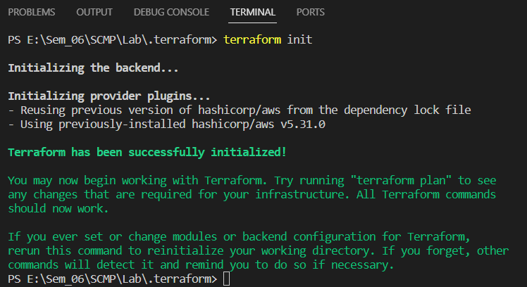

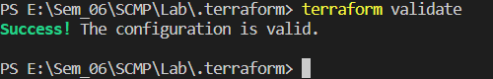

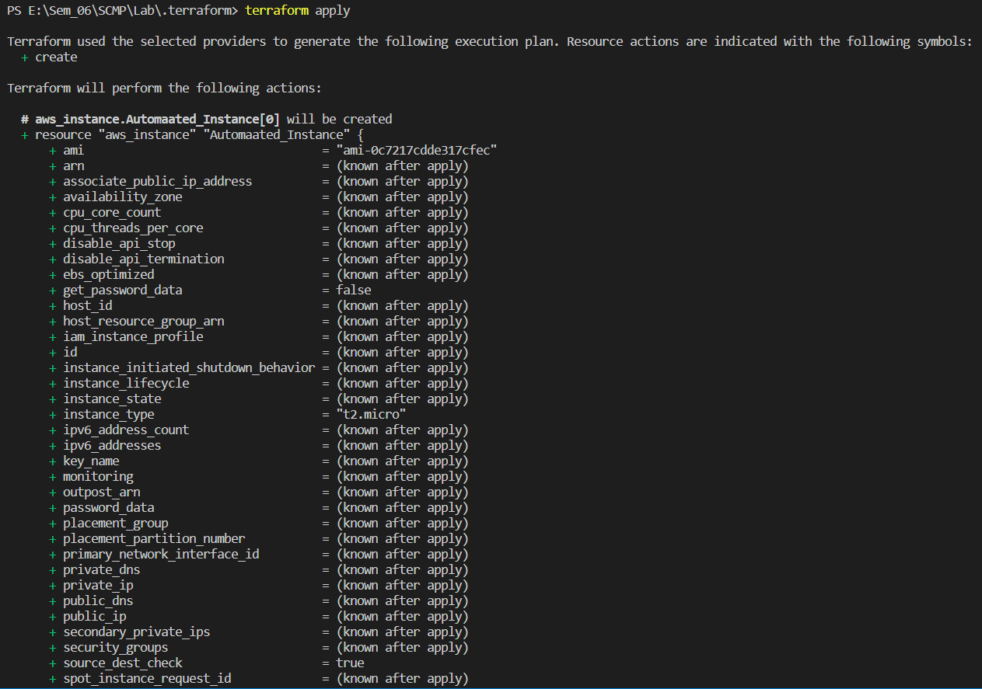

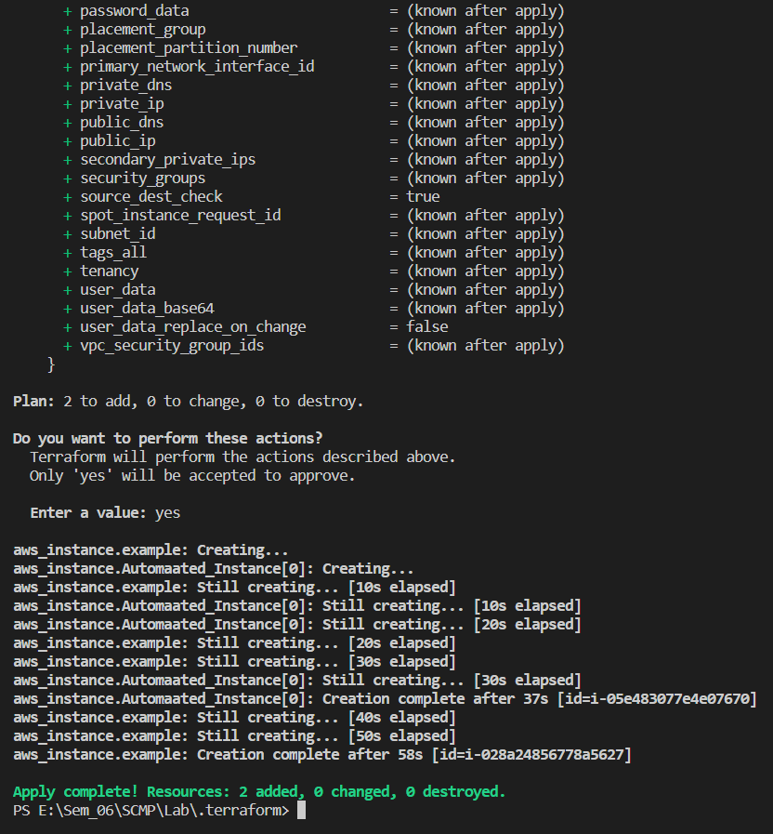

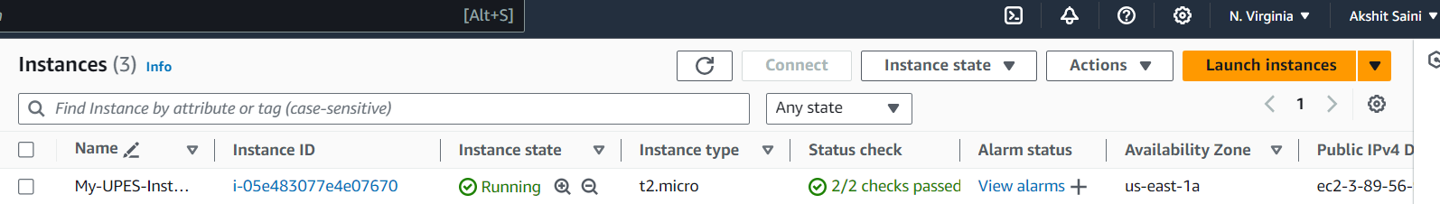

1. **Clean Up:**

